FILE PERMISSION TASK

Q: Create a file with .txt extension (/home/demo.txt). Change the permission set of that file, so that any user can read it, group can read/write & owner can read/write/execute it.

OUTPUTS:

Initially created a directory filepermissiontask

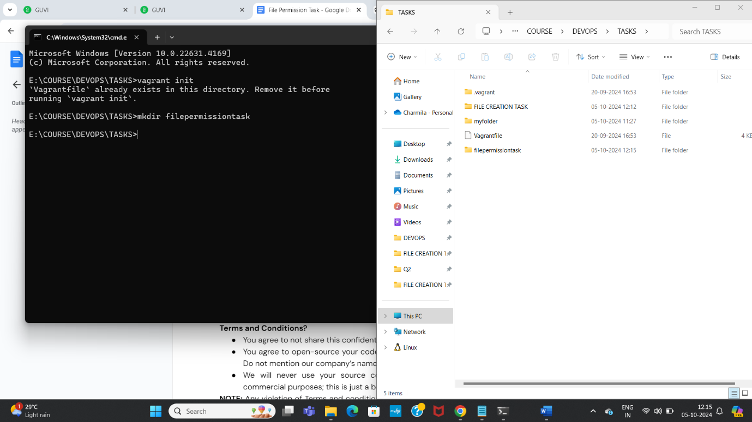

Created a file demo.txt

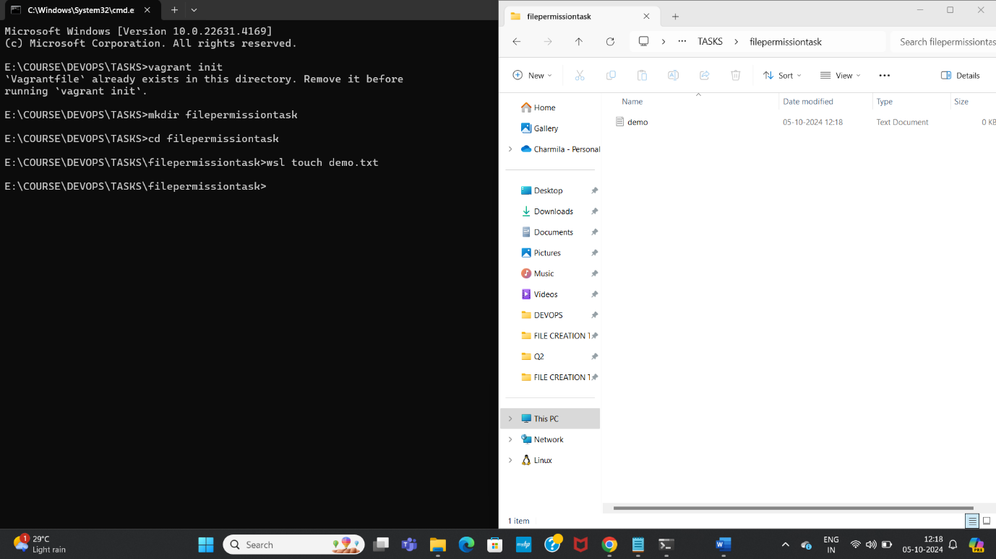

Viewed the initial permissions of the file demo.txt

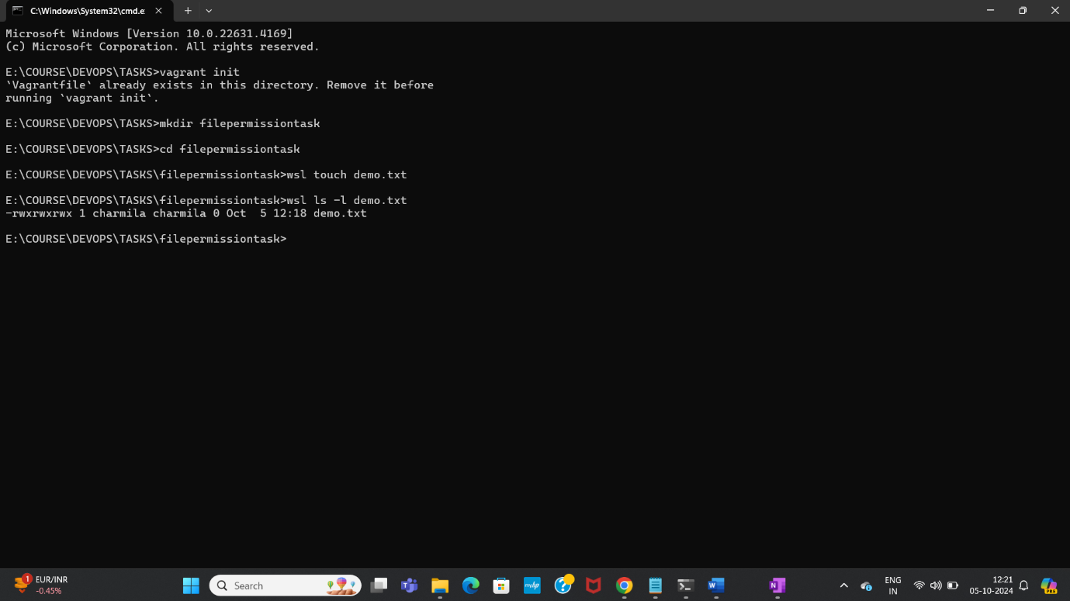

Changed the permissions of the file- not getting the required output-need to check

